**REQUIZA CLUB**

**REQUIZA CLUB:-**

REQUIZA- It is the official Technical Club of the Electronics and Communication Department (ECE), ABESEC. The Club started its journey in the year 2017.

It provides the best platform where students can learn and showcase their talent and technical innovations.

This club also helps to enhance the communication and interpersonal skills of the students and provide a holistic personality development.

It also helps in Building Social Network, Enhancing Your Resume, Community Engagement and Fun and Enjoyment. It's an opportunity to pursue your passions, have fun, and create lasting memories with friends.

President (Requiza) : Prof.(Dr.) Priyanka Bharadwaj

HOD, ECE

Club Counseller (Requiza) : Ms. Unnati Mehta

**Mission:-**

To create an environment of technical skill and create interest among students in their core field by providing responsive enrollment.

To foster a vibrant and supportive community among students interested in electrical engineering, computer engineering, and related fields.

To provide opportunities for academic and professional growth, hands-on learning experiences, and networking opportunities with industry professionals.

Our club strives to promote innovation, collaboration, and leadership within the ECE community while contributing to the advancement of technology and addressing societal challenges through engineering solutions.

Through a variety of activities, events, workshops, and projects, we seek to inspire, educate, and empower our members to excel in their academic pursuits, develop valuable skills, and make a positive impact in the world.

# OBJECTIVE:-

Encourage students to exchange the technical knowledge, ideas, and expertise among members through webinars, seminars, presentations, discussions and events.

**Fostering Innovation and Creativity:** Encourage members to innovate and create new technologies or improve existing ones, focusing on practical solutions to real-world problems.

**Skill Development:** Offer workshops, seminars, and hands-on projects to enhance technical skills in areas like coding, welding, data analysis, and more.

**Industry Interaction:** Facilitate interactions with industry professionals through guest lectures, internships, and collaborative projects to provide exposure to real-world practices and career guidance.

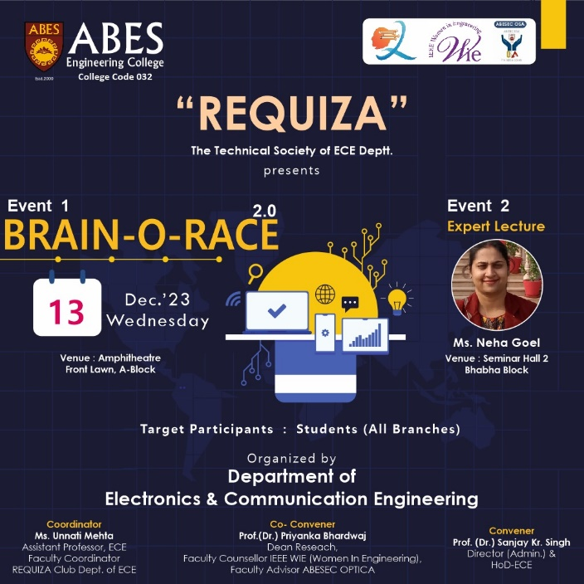

Brain-o-race

# EVENTS Held Under REQUIZA CLUB:-

* Technical Event- Brain-O-Race 2.0, 13th December2023
* Technical Event- Pen Down Your Perusal, 1st May2023
* Technical Event- Brain-O-Race, 27th December 2022
* Technical Event- Circuitron,18th &19th November2022
* Technical Event- TechWar,30th September2022
* Technical Event- Buzz-In-1 2.0, 22,25,26 April2022
* Technical Event- PREP QUIZ,11th & 12th March 2022
* Webinar on Career opportunities after Engineering,29th January 2022.
* Technical Event- "HIT THE MIND" 11th & 12th December 2021.
* Technical Event- "Teaserevia"18th November 2021.
* Technical Event- "Buzz-In-1"17th -19th June 2021 under ISTE SOCIETY.
* Technical Event-“KICK START” under IEI Society on 13th of February, 2020.
* Workshop- "MACHINE LEARNING" under IEI Society on 25th of January, 2020.
* Workshop- "EMBEDDED SYSTEM" under IEI Society on 24th of September, 2019.
* Technical Event- "BRAINATHON" on 05th -6th of September, 2019.
* Technical Event- "I SPY SCIENCE" on 13th - 16th of July, 2019.
* Workshop- "IMPORTANCE OF DIGITAL ELECTRONICS" under IEI Society on 09th of April, 2019.
* Technical Event- "HIT THE LOGO" under ISTE Society on 07th of February, 2019.
* Technical Event- "CIRCUITRON" under ISTE Society on 30th of October, 2018.
* Technical Event- “QUIZ BEE” under ISTE Society on 27th September, 2018.
* Technical Event- "QUIZZICAL MINUTES" under ICEIT Society on 22nd of March, 2018.
* Technical Event- "GRALITZ" under ICEIT Society on 7th, 8th and 9th of February, 2018.
* Technical Event- “FREEONZ” under ISTE Society on 14th and 15th September, 2017.